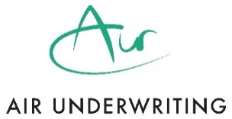
Product Governance and Fair Value Assessment
Air Underwriting is committed to conducting its business in a fair, honest and open manner and we ensure that we have appropriate product oversight and governance systems and controls in place to offer products that have been assessed as providing fair value to customers that are within the appropriate target market.
This summary document has been created to fulfil our responsibilities under fair value regulations.
This document should not be used as a sales or marketing tool. The client facing broker must act in the best interests of each customer individually when deciding whether to recommend a particular policy or not.

Product Information
Product | Air- Liability Insurance- Prior Submit

Assessment
Most Recent Review | July 2024
Product Type | Liability Insurance
Manufacturer/ Co Manufacturer | Axis Specialty Europe SE
Territorial Limits | United Kingdom, the Channel Islands and the Isle of Man, and elsewhere in the world in respect of temporary visits by employees normally resident in the United Kingdom, the Channel Islands and the Isle of Man.  In respect of product liability cover is granted worldwide but excluding USA and Canada (unless otherwise agreed by the Insurers)
Target Market | UK Micro and SME Businesses
Outside Target Market | All others outside of the Target Market
Characteristics of the Product aimed at meeting the needs of the target market | Employers Liability: The Product cover the Insured’s legal liability to pay damages, including defence costs, for injury to an employee which occurs in the course of their employment.  Public Liability: The Product covers the Insured’s legal liability to pay damages, including defence costs, for accidental injury and/or accidental damage incurred in connection with the business.  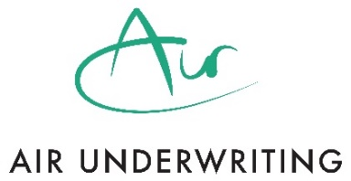  Products Liability: The Product covers the Insured’s legal liability to pay damages, including defence costs, for accidental injury and/or accidental damage arising out of or in connection with any product connected to their business.  See the Information Product Information Document and Policy Wording for full details of cover and relevant exclusions.
Distribution Strategy | This product is intended for distribution via FCA authorised brokers only. Brokers must be approved by us and enter into our standard format TOBA. Brokers may access this product via a broking submission. Sub- broking is not permitted.
Commission | We will agree a commission rate with each distributor. All distributors should be able to demonstrate that commission received bears a reasonable relationship to the actual costs of their contribution/level of involvement or benefit added by them to the distribution arrangement. We may ask you to justify your commission rate.
Other Renumeration | We will charge an Underwriting Fee on all policies. We will also charge a fee if your customer requests a mid-term adjustment or asks to cancel the policy during its term (other than in the cooling off period). Full details of our fees can be found within the quote documentation pack. We review our fees annually to ensure that they remain appropriate. We may ask you provide details of remuneration you earn in connection with the sale of our policy. This includes any fees, premium finance earnings, earning from non-insurance products or add-ons sold alongside our policy. You must ensure that your arrangements are consistent with FCA rules on conflicts and incentives. You should review all remuneration arrangements at least annually and share the outcome of that review with us on request.
Fair Value Review | Our product governance process requires a full review of all products at least annually to determine if the product offers fair value to the end customer. These reviews consider the target market, distribution strategy, remuneration, marketing, product information, product performance, product design and feedback from distributors and customers. We also monitor conversion rates, renewal retention, cancellations, loss ratios, claims and complaints as part of this review process. We are satisfied that the product offers fair value to its intended Target Market subject to distributors  - not charging customers additional amounts over and above the gross premium plus underwriting fees quoted by us without first determining that they do not have a detrimental effect on the value of the product.  - Ensuring that no duplicate cover exists or is caused by an add-ons where that cover is already provided by the policy
Customers for whom the product is not expected to provide fair value | This product would not be expected to provide fair value to policyholders/risks that fall outside of the Target Market.
Relevant documents available via our website | Information Product Information Document  Policy Wording

